29th May 2017

**Adriatic Rally in Italy - One to remember for YOKOHAMA**

The prestigious Rally Adriatico which is taking place in Italy, brought satisfaction to Yokohama Italia at the last race. Nicolò Marchioro, leader of the Italian Rally Terra Championship, managed a meritorious fourth place overall thanks to his talent and the ability to cope with the demanding tracks.

Good news also for the Yokohama Trophy, where the number of participants 11, represented a quarter of the total number of entrants. In addition to the most satisfying result of the young driver Marchioro on a Peugeot 208 T16 R5 of the Munaretto team, it is also significant to highlight the performance of Gigi Ricci on his Ford Fiesta R5 of the Bertino team. Following an uphill start, due to a penalty of 10” in the first half of the stage, due to a flying start, Ricci fought stage by stage winning two of them and ranking third in the CIRT.

According to Giuseppe Pezzaioli, Yokohama Italy’s Motorsport Manager, "The Adriatico Rally has been very positive for Yokohama, as well as for the official drivers and for the Trofeo contenders who have displayed a superb performance,". Adding, "We are always performing well on the hard tracks and the Trofeo drivers are getting more and more confident with the Yokohama tyres. This is an important year for us, in which we are growing on all fronts." He concluded.

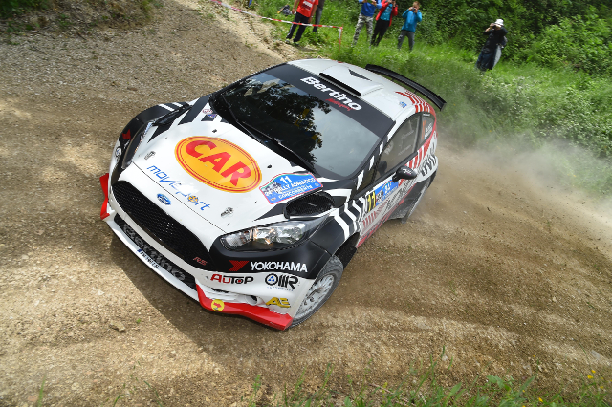

*Exciting Rally in Italy with Yokohama*

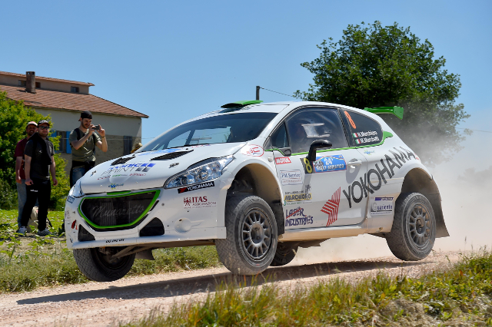

*Marchioro does well at Adriatico Rally*

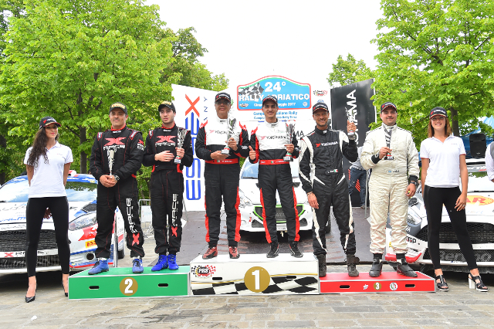

*Podium at Trofeo Rally Terra in Italy*